AI WeatherWise
Delivering Intelligent Weather Forecasts and Insights
Technical Documentation

Project Team
S. Santhiya
Rajalakshmi
Parameshwari
Zeba Fathima

Table of Contents
1. Overview
2. Requirements
3. System Architecture
4. Entity-Relationship Model
5. Project Setup
6. Core Backend Scripts
7. Running and Testing the API
8. Reference Links

1. Overview
AI WeatherWise is a REST API service that delivers intelligent weather forecasts and AI-generated insights. The backend runs on Node.js and Express.js, with MongoDB as the primary datastore accessed through the Mongoose ODM.
The platform combines a live weather data source (OpenWeatherMap) with Google's Gemini AI to turn raw weather readings into plain-language summaries and practical recommendations for the user. JSON Web Tokens (JWT) secure user accounts and protected routes, and a centralized error-handling layer keeps API responses consistent and predictable.

Highlights
- JWT-based Authentication: Registered users get a signed token used to access protected routes.
- Live Weather Data: Current conditions are fetched for any city through an external weather API.
- AI-Generated Recommendations: Google Gemini AI turns weather conditions into short, practical advice for the user.
- Saved Locations: Users can save and favorite locations for quick lookup.
- Centralized Error Handling: A single handler standardizes error responses and a 404 handler catches unmatched routes.
- RESTful Design: Modular Express routers keep auth, locations, weather, and AI logic cleanly separated.

2. Requirements

2.1 Software Requirements
Component | Details
Operating System | Windows 10/11, macOS, or Linux — the stack runs cross-platform.
Node.js | v18 or newer — the JavaScript runtime that executes the server logic and routing.
npm | Manages the project's package dependencies.
Express.js | The lightweight web framework used to build RESTful endpoints.
MongoDB + Mongoose ODM | The NoSQL document store holding users, locations, and weather records.
OpenWeatherMap API key | Supplies live current-weather data for requested cities.
Google Gemini API key | Powers AI-generated weather summaries and recommendations.
Postman | Used to exercise the API and confirm route and auth behavior.
Code Editor | Visual Studio Code or an equivalent IDE.

2.2 Hardware Requirements
Component | Details
Processor | Intel Core i5 (8th generation or later) or an equivalent AMD Ryzen 5.
RAM | 8 GB minimum; 16 GB recommended when running MongoDB alongside the dev server.
Storage | At least 1 GB of free disk space.

3. System Architecture
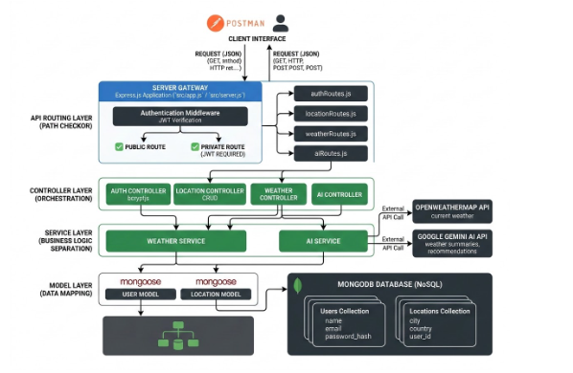
Figure 1: Technical architecture of the AI WeatherWise API
Every incoming request passes through a layered pipeline before a response is returned.

Layer-by-Layer Breakdown
- Client Interface: Postman (or any REST client) sends JSON requests and receives JSON back.
- Server Gateway: The Express application (app.js / server.js) receives every request and runs the authentication middleware, which verifies the JWT on private routes.
- API Routing Layer: Requests are dispatched to authRoutes.js, locationRoutes.js, weatherRoutes.js, or aiRoutes.js depending on the path, after the public/private check.
- Controller Layer (Orchestration): Auth, Location, Weather, and AI controllers validate input and coordinate the work for each request.
- Service Layer (Business Logic): The Weather Service calls the external OpenWeatherMap API for current conditions; the AI Service calls the Google Gemini API for weather summaries and recommendations.
- Model Layer (Data Mapping): Mongoose User and Location models map application data onto MongoDB documents.
- MongoDB Database: Stores the Users and Locations collections (and related data) as NoSQL documents.

4. Entity-Relationship Model
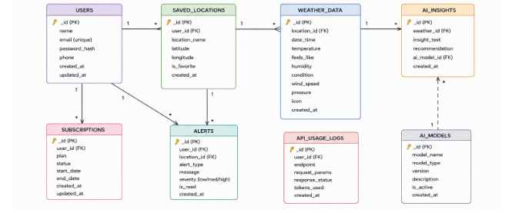
Figure 2: Entity-relationship diagram for AI WeatherWise
The database is composed of several MongoDB collections linked by logical references, together covering user accounts, saved locations, weather history, and AI-generated insights.

Users Collection
Field | Type / Rule
_id | Primary key (ObjectId)
name | String
email | String, unique
password_hash | String, hashed
phone | String
created_at / updated_at | Timestamps

Saved Locations Collection
Field | Type / Rule
_id | Primary key (ObjectId)
user_id | Reference to the Users collection
location_name | String
latitude / longitude | Number
is_favorite | Boolean
created_at | Timestamp

Weather Data Collection
Field | Type / Rule
_id | Primary key (ObjectId)
location_id | Reference to Saved Locations
date_time | Timestamp
temperature / feels_like | Number
humidity / wind_speed / pressure | Number
condition / icon | String
created_at | Timestamp

AI Insights Collection
Field | Type / Rule
_id | Primary key (ObjectId)
weather_id | Reference to Weather Data
insight_text | String
recommendation | String
ai_model_id | Reference to AI Models
created_at | Timestamp

Supporting Collections
- Subscriptions: plan, status, start_date, end_date — linked to a user.
- Alerts: alert_type, message, severity, is_read — linked to a user and a location.
- API Usage Logs: endpoint, request_params, response_status, tokens_used — linked to a user.
- AI Models: model_name, model_type, version, description, is_active — referenced by AI Insights.

How the Pieces Connect
- Users → Saved Locations (one-to-many): A user can save multiple locations.
- Saved Locations → Weather Data (one-to-many): Each location accumulates a history of weather readings.
- Weather Data → AI Insights (one-to-many): A weather reading can produce one or more AI-generated insights.
- Users → Subscriptions / Alerts / API Usage Logs (one-to-many): Account-level records tied back to the owning user.

5. Project Setup

Folder Structure
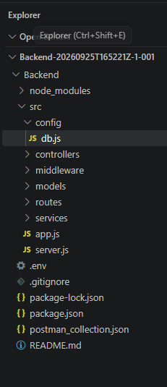
Figure 3: Initial project folder structure in the VS Code explorer
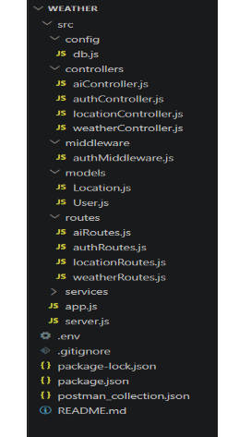
Figure 4: Full project directory structure once all modules are in place

Installing Dependencies
From the project root, open a terminal and run:
npm install
Then start the development server:
npm start
After successful execution, the server connects to MongoDB and starts listening for incoming API requests.

6. Core Backend Scripts

1. Entry Point (src/server.js)
This is the application's launch point — it loads the Express app, opens the database connection, and starts listening on the configured port. If the database connection fails, the process exits instead of starting the server.
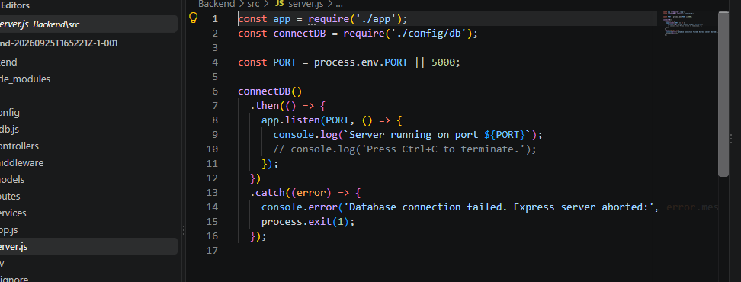
src/server.js

2. Express App Setup (src/app.js)
Configures the core Express instance: CORS, JSON body parsing, environment variables, and the route modules for auth, locations, weather, and AI.
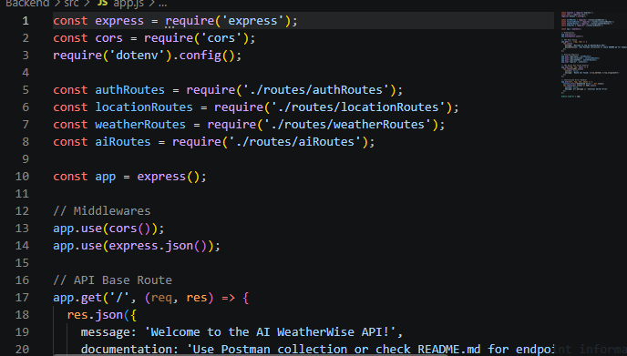
src/app.js — middleware, routes, and base route
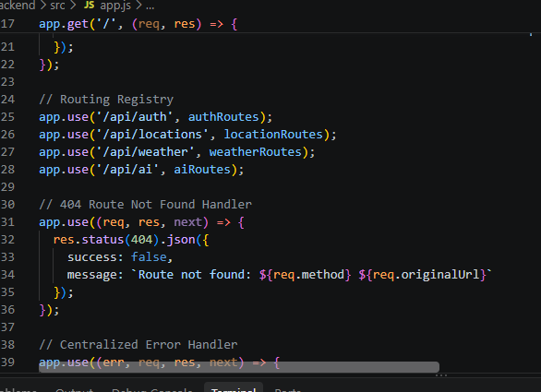
src/app.js — routing registry, 404 handler, and centralized error handler

Routes
- authRoutes.js: Registration and login endpoints.
- locationRoutes.js: CRUD endpoints for a user's saved locations.
- weatherRoutes.js: Fetches current weather for a given city.
- aiRoutes.js: Generates AI-powered weather summaries and recommendations.

7. Running and Testing the API
The requests below confirm that each endpoint behaves as expected.

1. User Registration
- Route: POST /api/auth/register
- Access: Public
Sample request body:
{
"name": "John Doe",
"email": "john@mail.com",
"password": "123456"
}
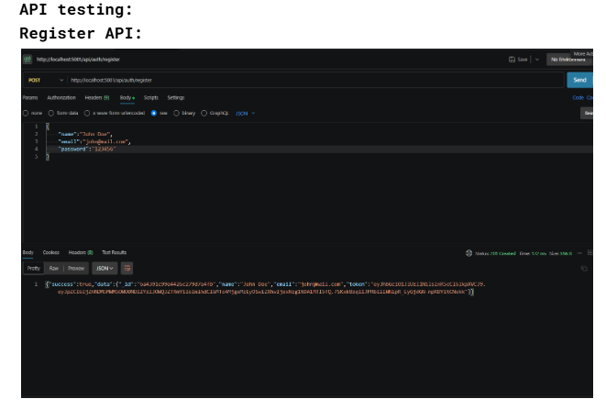
Figure 5: Successful registration response, returning user details and a JWT

2. User Login
- Route: POST /api/auth/login
- Access: Public
Sample request body:
{
"email": "john@mail.com",
"password": "123456"
}
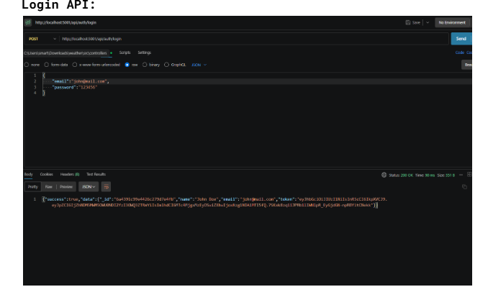
Figure 6: Login response returning a JWT

3. Weather Lookup
- Route: GET /api/weather/:city
- Access: Private (Bearer <JWT Token>)
Sample request — GET /api/weather/bangalore:
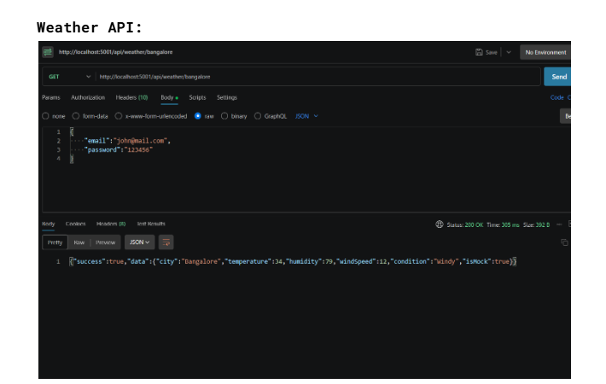
Figure 7: Current weather conditions returned for Bangalore

4. AI Weather Recommendation
- Route: POST /api/ai/weather-recommendation
- Access: Private (Bearer <JWT Token>)
Sample request body:
{
"city": "Bangalore",
"temperature": 34,
"humidity": 79,
"condition": "windy"
}
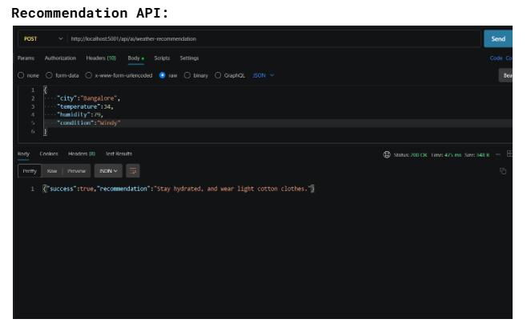
Figure 8: AI-generated recommendation based on current conditions

8. Reference Links
Project Demo: https://drive.google.com/file/d/1bj6l5W3F6zHBfau8au_0p04kmjnyhVt3/view?usp=drive_link
Api testing: https://drive.google.com/file/d/1NjpD7YP7lCY215wxMHQdKX4YRcEdHDL-/view?usp=drive_link

